**Full Deployment Examples**

The following screenshots provide example of how the technology is expected to look if fully configured.

1. [Citrix Virtual Apps & Desktops](https://support.goliathtechnologies.com/hc/en-us/articles/360025155613-Full-Deployment-Examples#h_01FYW4WB99F3KTP27EM2PHHT2T)
2. [VMware Horizon](https://support.goliathtechnologies.com/hc/en-us/articles/360025155613-Full-Deployment-Examples#h_01FYW4WMQ1SA3D8S3T65HAVS2M)
3. [Epic System Pulse](https://support.goliathtechnologies.com/hc/en-us/articles/360025155613-Full-Deployment-Examples#h_01FYW4WZWNA3HJ1GJW6XJGH5K6)

**Citrix Virtual Apps & Desktops**

(Formerly XenApp & XenDesktop)

There are few screens that will indicate that the Citrix API has been enabled and is working

**Configure - Inventory**

1. You will see your XenApp Servers and or XenDesktop VDI machines listed on this page
2. The XenApp Servers and/or XenDesktop VDI machines, machines with the VDA installed - not infrastructure servers, will have a blue circle Citrix icon in the **OS** column and the **Group** column will state the name of the Citrix Delivery Group they belong to.
3. A green square in the **Agt** column indicates that an agent is installed and successfully connected

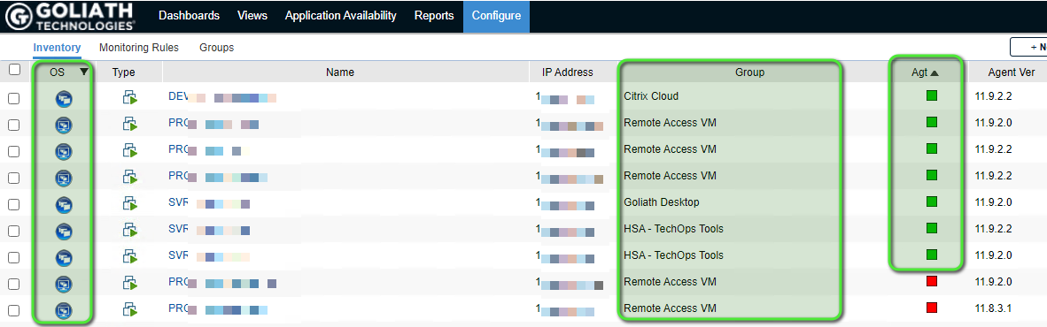

**Views - Citrix Virtual Apps & Desktops**

This page of the technology is broken into 3 tabs. Confirm data is populated onto the tab(s) as applicable for your environment.

**App Servers**

This tab is only applicable for Virtual Apps environments (Formerly XenApp)

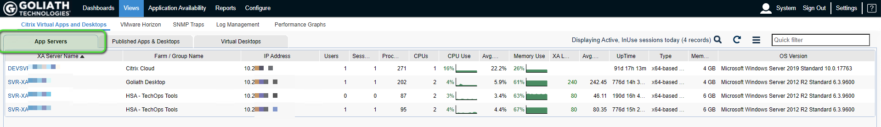

**Published Apps & Desktops**

This tab is only applicable for Virtual Apps environments (Formerly XenApp)

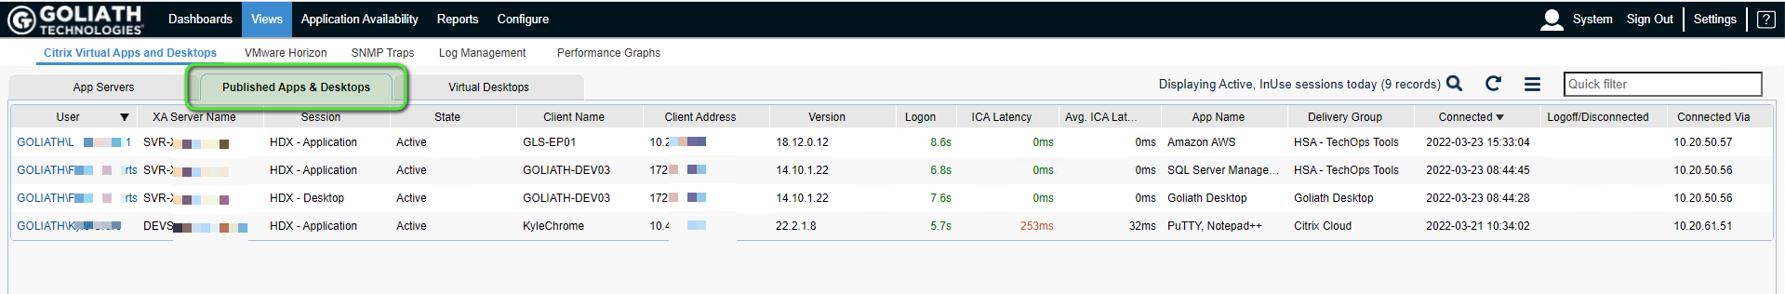

**Virtual Desktops**

This tab is only applicable for Virtual Desktop environments (Formerly XenDesktop)

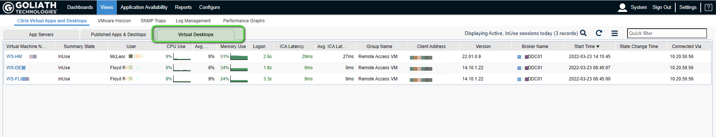

**Dashboards - Topology**

This feature requires an additional license. Please confirm you are licensed for this page.

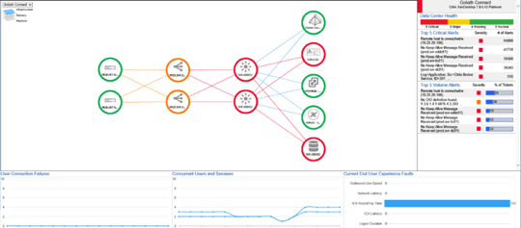

**VMware Horizon**

There are few screens that will indicate that the Horizon API has been enabled and is working.

**Configure - Inventory**

1. You will see your VMware machines listed on this page
2. When looking at the VMware App and/or Virtual Desktop machines, ensure that there is a green square in the **Agt** column which indicates that an agent is installed and successfully connected

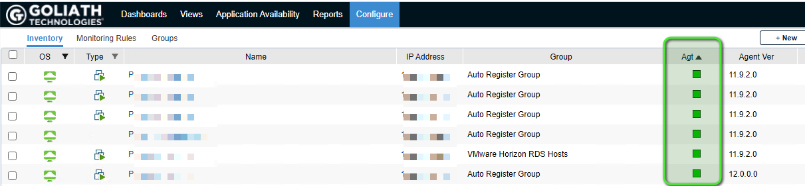

**Views - VMware Horizon**

This page of the technology is broken into 3 tabs. Confirm data is populated onto the tab(s) as applicable for your environment.

**App Servers**

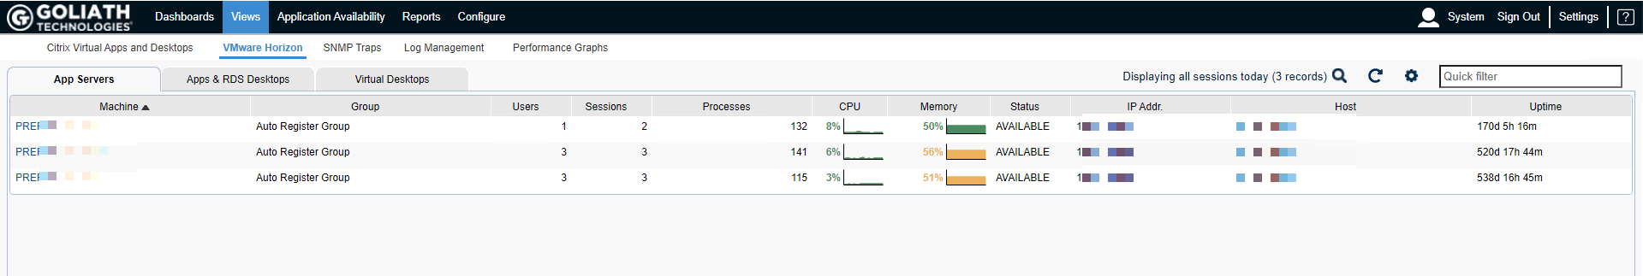

**Apps & RDS Desktops**

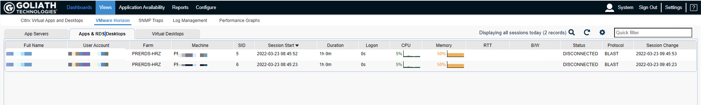

**Virtual Desktops**

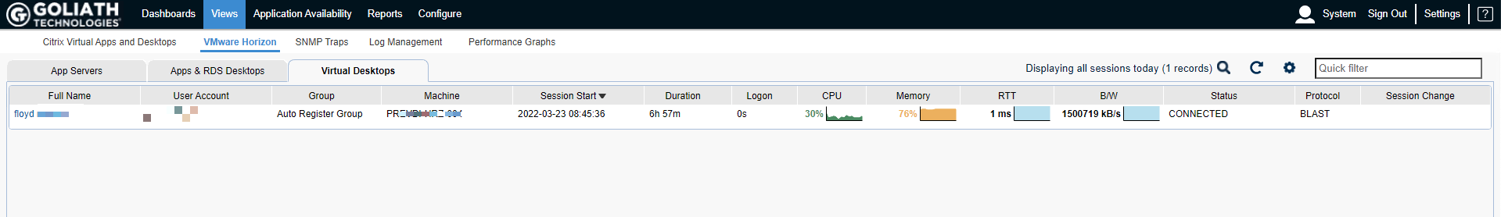

**Epic System Pulse**

There are 2 dashboards that will be populated if the Epic System Pulse Module is fully configured.

From the **Views** tab and clicking on the **Performance Graphs** submenu option allows you to view the dashboard-style performance graphs for Epic.

From the top **Dashboards** section of the left hand menu pane, you can view the Epic System Pulse information collected by clicking on the check box to the left of the folder named **Epic** and then clicking on the large **+** symbol in the middle of the screen labeled **Add Dashboard from Left Pane**

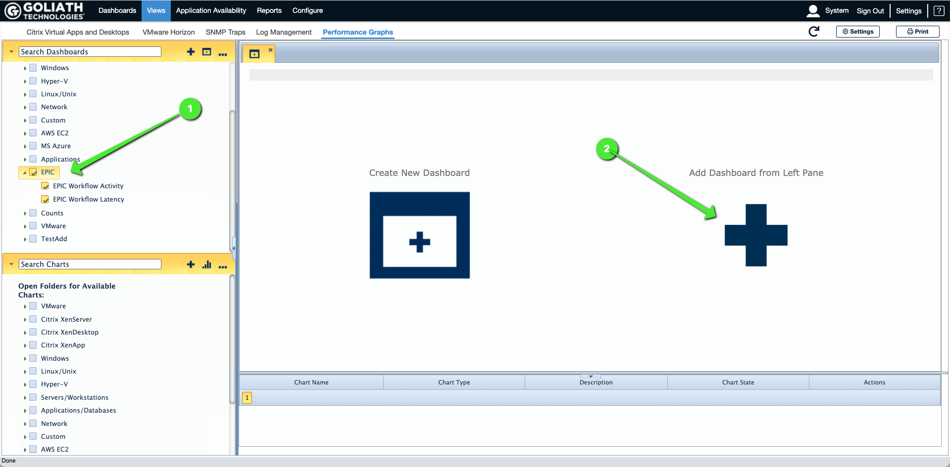

The two dashboards related to monitoring Epic Workflow & Activity will appear and look like this:

